Young Mediterranean Voices
Hub Appointments
June 2018 - December 2018

OVERVIEW
YOUNG MEDITERRANEAN VOICES is primed to become the central flagship regional youth network connecting youth across Europe and the Neighbourhood South (Southern Mediterranean and Europe).
Building on more than five years investment in the field, as well as established networks, pioneering methodologies and independent research, the overall objective of Young Mediterranean Voices programme is to: Empower young people to enhance a culture of dialogue and to create a shared understanding with peers across the Mediterranean on how to address issues of common concern to their communities.
This programme will bring the experience of Arab youth-led debate to other parts of the Euro-Mediterranean region. One of the most pioneering aspects of this programme is to contribute to enhance the “Euro-Med dialogue” paradigm by bringing the experience of a pan-Arab programme to the North and consequently challenging the traditional cooperation dynamics that were dominated by programming towards the South.
This project is grounded on the positive experience of Young Arab Voices and benefits from the support of the EU. “The EU will support the second phase of the Young Arab Voices programme to deepen the dialogue between young leaders and civil society representatives".
Young Mediterranean Voices has 4 inter-related strategic objectives through which we will deliver the programme:
- train young people in debate and dialogue techniques, and equip them to participate more effectively in their communities and enhance their life opportunities;
- provide further leadership development opportunities to young people (Young Mediterranean Voices ambassadors), and equip them to engage with existing leaders and the media to influence public policy;
- equip young people with the skills to engage more successfully with social media;
- Provide opportunities for young people to engage together across the Euro-med region then build the networks for future collaboration and break down barriers and stereotypes that lead to a lack of intercultural dialogue.
The four strands build from country based training and capacity building to the regional level and onwards to a Euro-Med level. We will work with policy makers to gain access to education and other formal systems to deliver the programme. The programme will work with our ‘ambassadors’ to engage with traditional media and we will provide opportunities for them to engage in social media labs to practice content development to present positive narratives of young people and their contribution. Finally we will provide opportunities to connect north and south young people and partners to further the programmes objectives and create opportunities to enhance intercultural dialogue building mutual understanding and trust.

YOUNG MEDITERRANEAN VOICES INSTITUTION PARTNER
The major partner of Young Mediterranean Voices is the Ministry of Higher Education and Scientific Research. We encourage Debate Clubs existing in various universities and higher education institutions under the previous Young Arab Voices, and university students’ clubs to apply.
TARGET GROUPS AND FINAL BENEFICIARIES
The beneficiaries and stakeholders of the programme are divided into the following principal categories:
- Young people (“YMV community debaters”), in the participating programme countries, - principally aged 16 to 25 - from diverse backgrounds.
- Youth leaders (“YMV Ambassadors network”), who have gone through the first level of YAV Training and are primed to be involved in a next level of media and advocacy work,
- Young Mediterranean Trainers principally aged between 18 – 35 who have gone through the delivery of YMV trainings (national, regional and master levels)
- CSOs - Youth NGOs and Cultural Organisations; Educational Institutions – Schools and Universities (“YMV Debating Hubs”) working at the delivery level and benefiting directly from the programme’s capacity-building measures, exchange schemes and support.
- Decision-makers who can benefit from knowing the priorities and needs of their young constituency and hearing their direct and credible voices that would inform their planning and decisions.
- Media interested in having access to authentic voices that are not usually heard in mainstream media, as well as organisations working in the domain of digital media and digital debate facilitation.
- Public sector institutions, interested in promoting education and social development as well as open and pluralistic society.

HUB ROLES
Young Mediterranean Voices have implemented a ‘Hub’ structure to ensure a greater geographical reach, whilst also engaging hard to reach and marginalised communities. The ‘Hub’ plays an important role in the delivery of the programme by cascading trainings and competitions nationally, and are those directly involved with the young people.
Each ‘Hub’ will be required to:
- Deliver and Cascade training to 750 number of Young People
- Deliver and Cascade training to marginalised and hard to reach areas
- Deliver Inter-Hub/University Competitions
- Develop ‘Clubs’ with 15 active participants as per country targets
- Monitor and Evaluate ALL trainings in hub remit
- Issue monthly ‘Progress Reports’ to country Project Manager

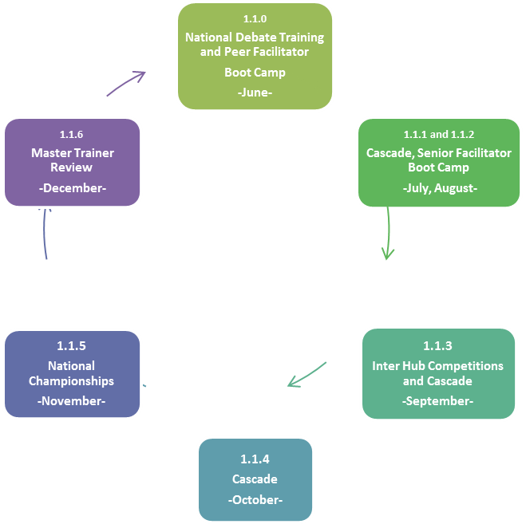

Young Mediterranean Voices
Hub Application Form

The details provided in this form will be used to evaluate your suitability to provide services to the British Council as part of the EU funded ‘Young Mediterranean Voices’.

All questions must be answered. Please do not leave blanks. You may use None or Not Applicable where appropriate.

General Information

Name of Debate Club / Students’ Club
Address
Telephone No |  | Fax
Website |  | Email
Facebook |  | Twitter

Contact details

Name | Position | Tel No/Mobile No | Email

Club details

Club Reg No (if applicable)
Name of University
Date of formation of your Club
Main activity of the club

Total number of members
Number of members by skill set (if applicable)
Management / Supervision |  | Clerical / Support
Operational |  | Marketing

Description of your core activity

Is Your Club a Debate Club or does it include Debate Activities? If yes please provide details and activity examples where applicable
Example 1: | Example 2:

Has your Club previously been involved with Young Arab Voices? If yes please list your current and previous programmes which relate to the former ‘Young Arab Voices’

Programme | Details

Please list all institutions and organisations you are inter-connected with for possible delivery.

Name | Details

Please specify the state from the map below, which can be covered by your club
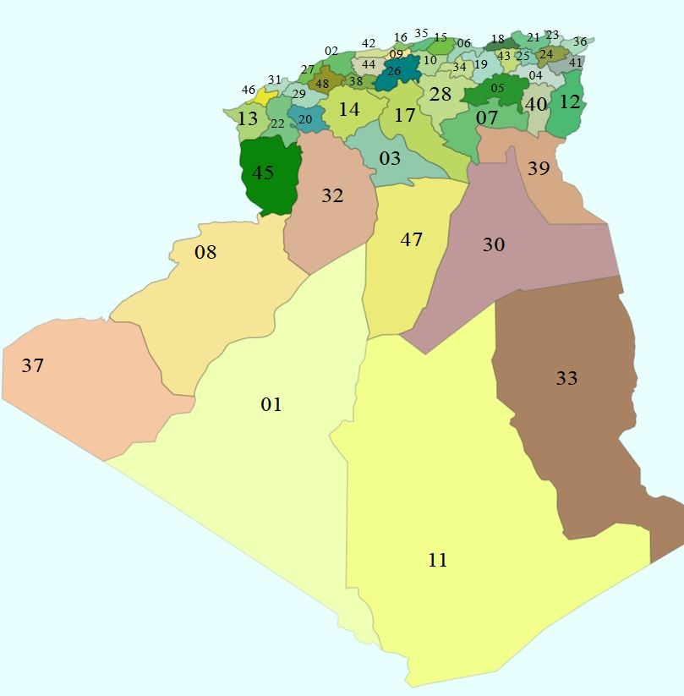
States targeted by your club :

Please number (to the nearest 100) your potential reach of students (evidence will be required)

References

References: Please supply at least two references we may contact in relation to the services delivered by your club (not British Council).

Company Name
Address
Contact Name |  |  | Tel No |  | Email
Number of years providing services to the business
Goods/services provided

Company Name
Address
Contact Name |  |  | Tel No |  | Email
Number of years providing services to the business
Goods/services provided

Diversity & Equality
Is it your practice NOT to discriminate directly or indirectly on grounds of race, disability, gender, and age, in the provision of goods, facilities and services to the public? | Yes |  | No
In the last 3 years has any finding of unlawful discrimination in ANY field been made against your organisation by an Employment Tribunal or any court or in comparable proceedings in any other jurisdictions or has your organisation been the subject of formal investigation (which had a negative finding) by relevant authorities (such as Equality and Human Rights Commission or its predecessors) on the grounds of alleged unlawful discrimination? | Yes |  | No

If your answer is Yes, please advise what the unlawful finding(s) was/were and what corrective actions have been taken by your organisation as a result.

Conflicts of Interest

To the best of your knowledge is any key employee or senior management of your organisation related by blood, marriage, current or past business association or otherwise) to a staff member at the British Council? If yes, please explain
If yes, please describe the relationship between such person(s)

Have you or any of your key employees or senior management member of your organisation, ever been convicted of a felony or any serious crime in the country where the services will be delivered or in any other country (other than traffic violations)? Are there any legal proceedings of this nature pending?

Declaration
We hereby certify that the information supplied is accurate to the best of my/our knowledge and understanding. We understand and accept that false information could result in exclusion from the selected list of suppliers.
Please send your application form before 08/04/18, to: YMV-Alg@britishcouncil.org
Name
Position
Date

The Education Institutions are those universities and schools interested in the development of soft skills through the participation of their student bodies, and will play a central role in advocacy for embedding debate curricula with the support of national Ministries.

